Zoom User and Role Creation

1. Login to zoom using licensed or paid account. Only licensed or paid user can create user and role.
2. Go to the below link .Some example user is created. <https://zoom.us/account/user#/>

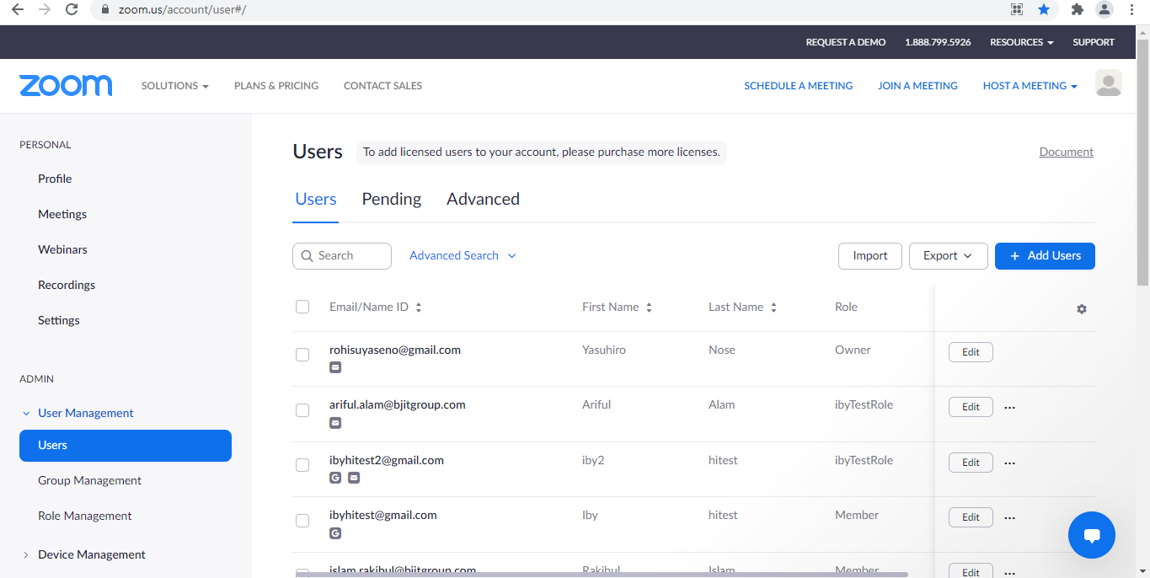

1. Click Add User button to create new user. One Activation mail is passed to the corresponding user email. User will not appear in user list unless the user Activate from the mail. It will appear in **“Pending”** list and will remove after 30 days if not activate.

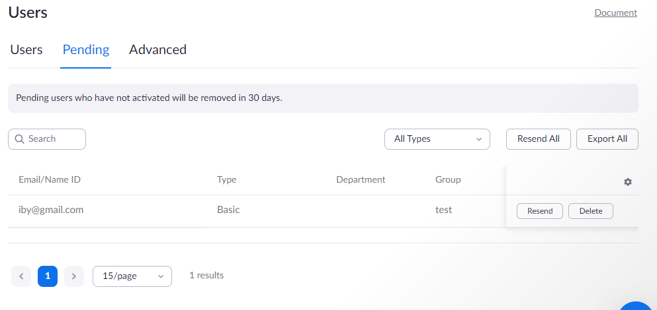

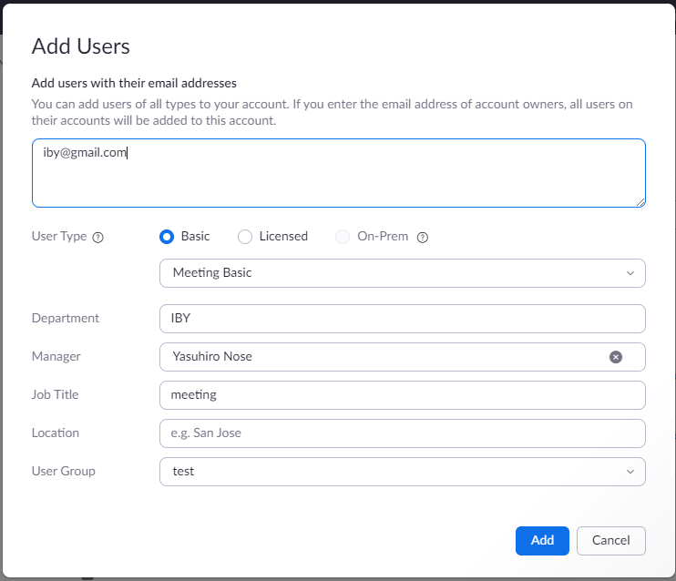

1. The member role predefined role is automatically apply all sub user . We need to create a new role that has more permission such get user data, creating meeting and login credential. Only member role may not provide credential access using 3rd party login .

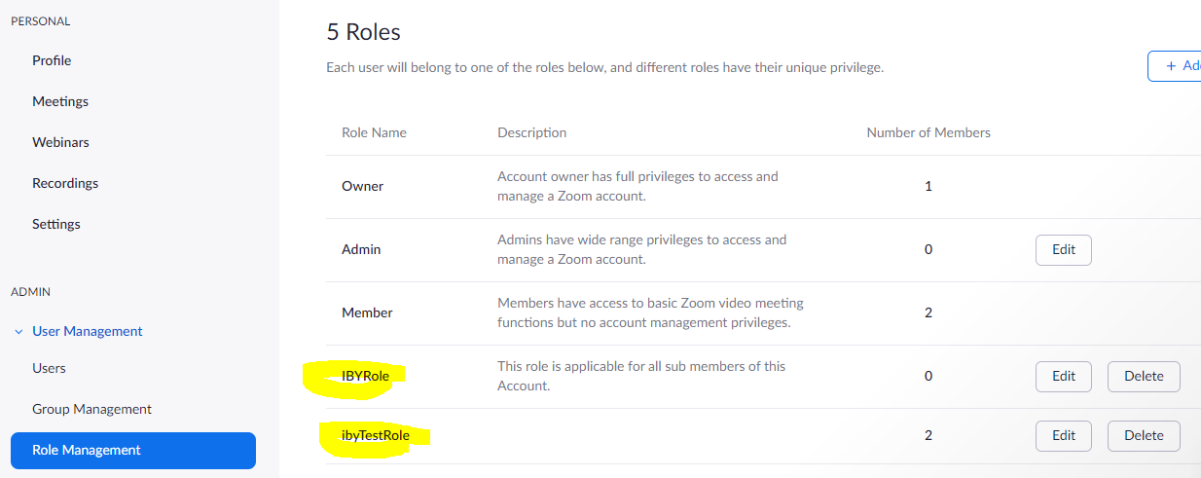

1. We already create two role IBYRole and ibyTestRole. We are checking “ibyTestRole” that has all oprtion of “member” role just User Permission is added.

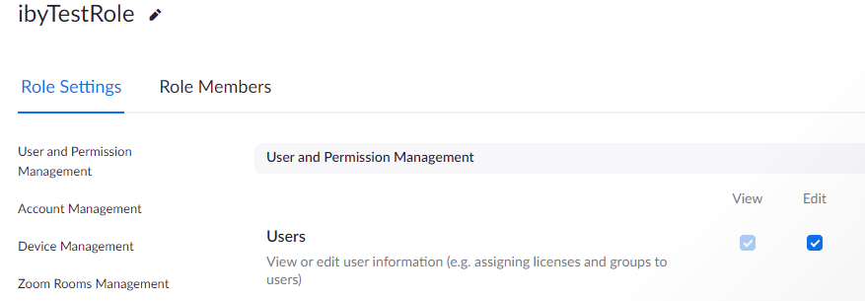

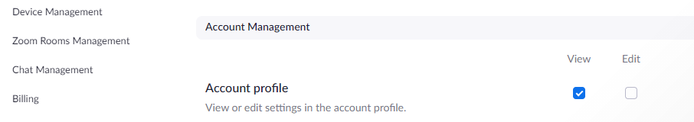

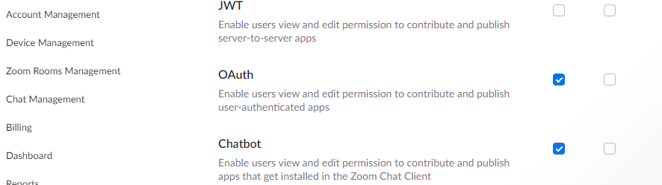

1. We can change any setting of the role using Edit option.
2. Assign role to a User. Edit User and just simply add role.

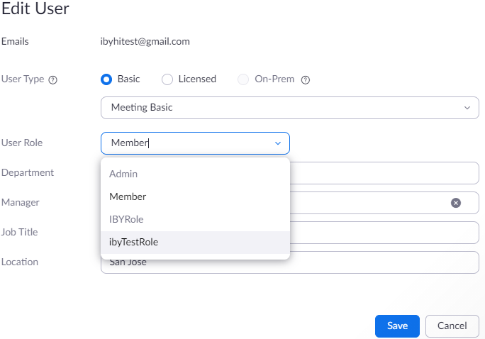

1. Creating Application for using Development.
2. Go to Zoom Market Place and Create OAuth App.

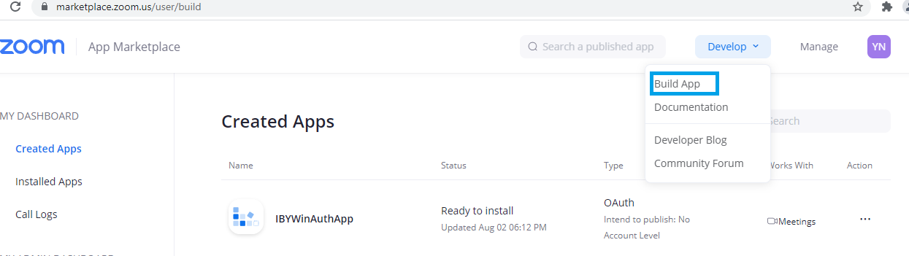

Click Build App option and this window appear. Click the Create button of OAuth panel.

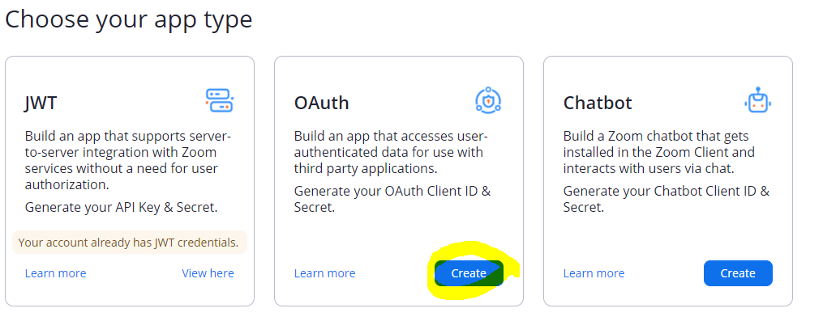

1. After Create button click below window appear. Select Account level app and if you want to publish in zoom marketplace check this. We are not publish the app so uncheck.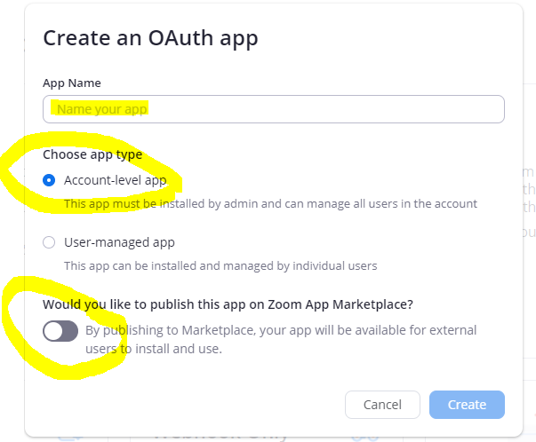
2. Now App Setting is appear.

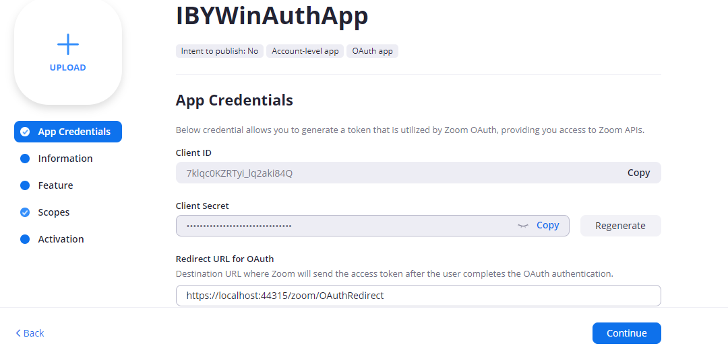

Redirect URL is mandatory filed .Zoom will send code to this url .Using code we need to get access token.

1. Add white list url.

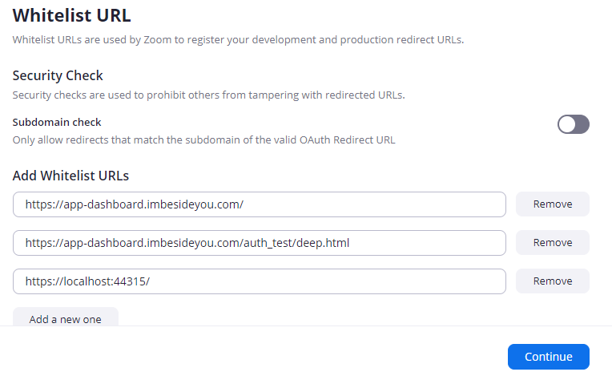

1. Add Information and Feature .
2. Add Scope. Don’t select any sub Account Scope .It is not allowed any sub users only Admin or master user can access this.

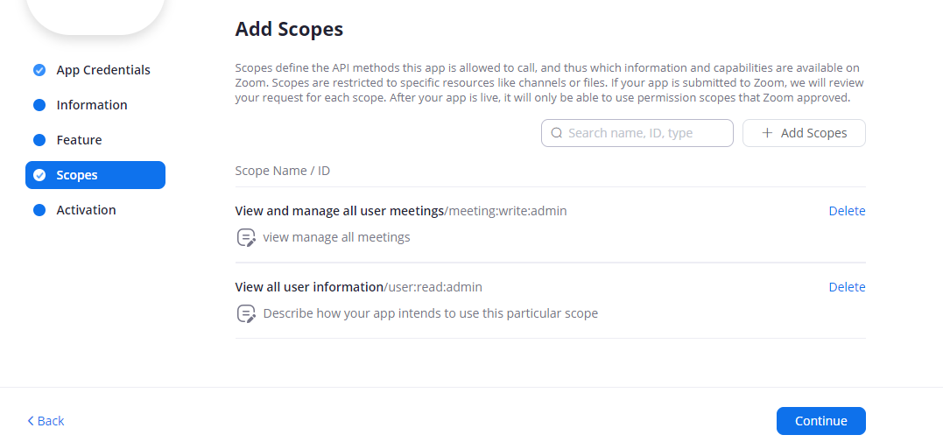

1. Click Add Scopes button. Hear we only select two option. You can add many more.

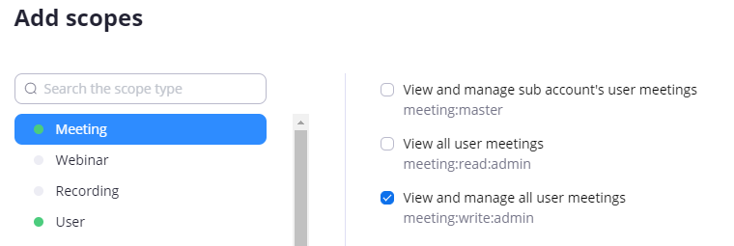

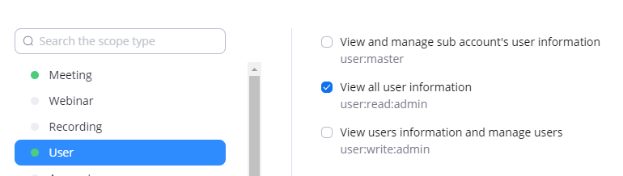

1. From App Credential option use the “Client ID” and “Client Secret” to use this App. Zoom provide code with the redirect url. Listen this url to get the code then call token Api
2. In C# we put some api in app.config file

<appSettings>

<add key="ClientId" value="7klqc0KZRTyi_lq2aki84Q" />

<add key="ClientSecret" value="slpb4grMErAlfT4f8whI3PoA4bL1mNdP" />

<add key="RedirectUrl" value="https://localhost:44315/zoom/OAuthRedirect" />

<add key="AuthorizationUrl" value="https://zoom.us/oauth/authorize?response_type=code&amp;client_id={0}&amp;redirect_uri={1}" />

<add key="MeetingUrl" value="https://api.zoom.us/v2/users/{0}/meetings" />

</appSettings>

1. Listen the RedirectUrl

string redirectURI = ConfigurationManager.AppSettings["RedirectUrl"] + "/"; var http = new HttpListener();

http.Prefixes.Add(redirectURI);

http.Start();

1. Get token from token API <https://zoom.us/oauth/token>
2. Meeting List API <https://api.zoom.us/v2/users/me/meetings>